Creation of the SecurEnds application

- Creation of a SecurEnds application is required so the Client ID and Client Secret can be generated for input into the SecurEnds configuration for the Salesforce connector.
- To create app, follow the below steps.

- Click on setup

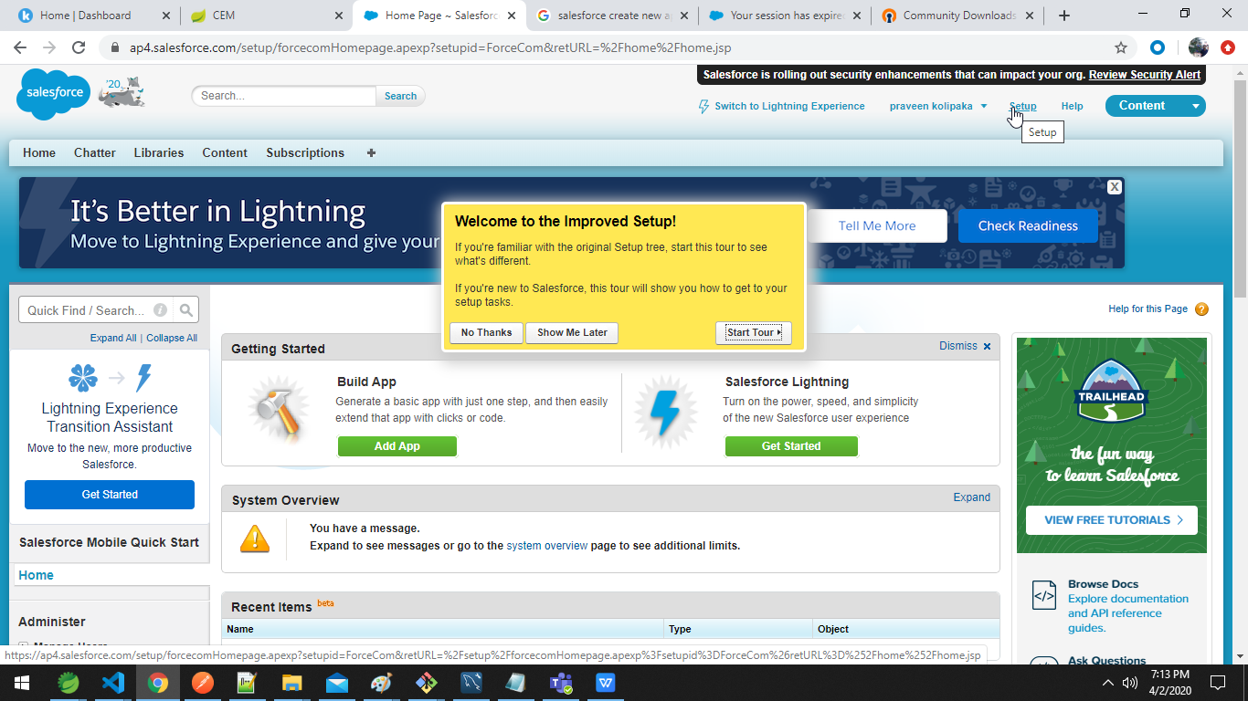

- Click on create > apps

- Click on new

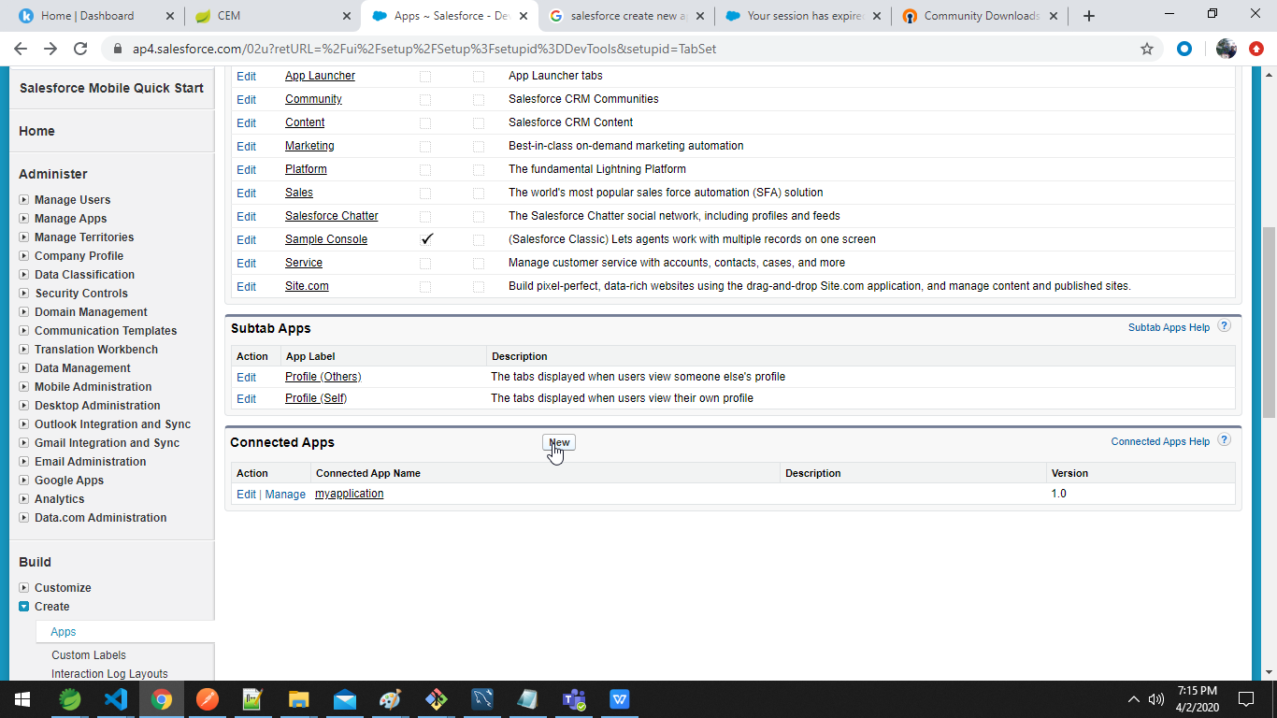

- Fill the form.

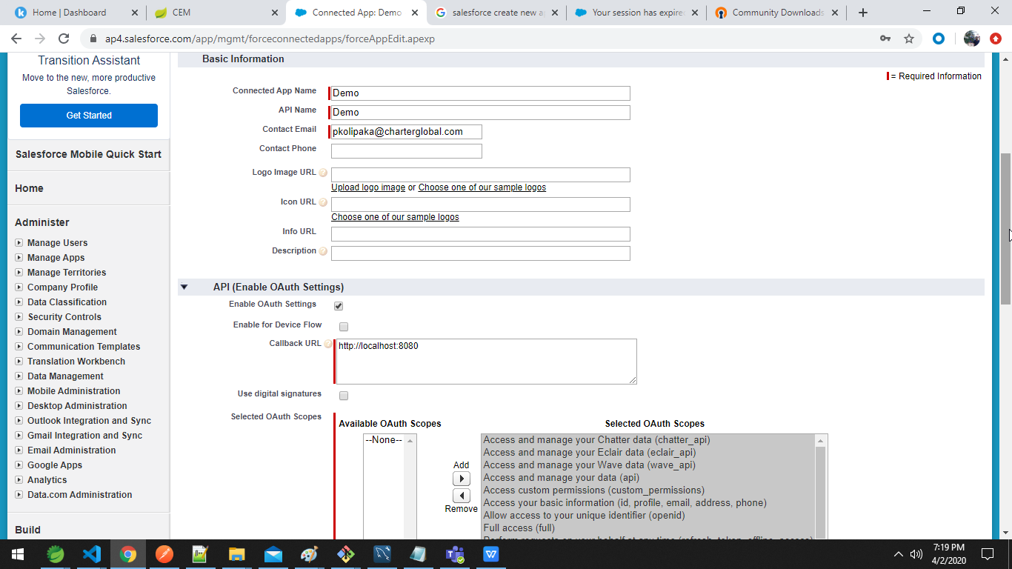

- Click on continue.

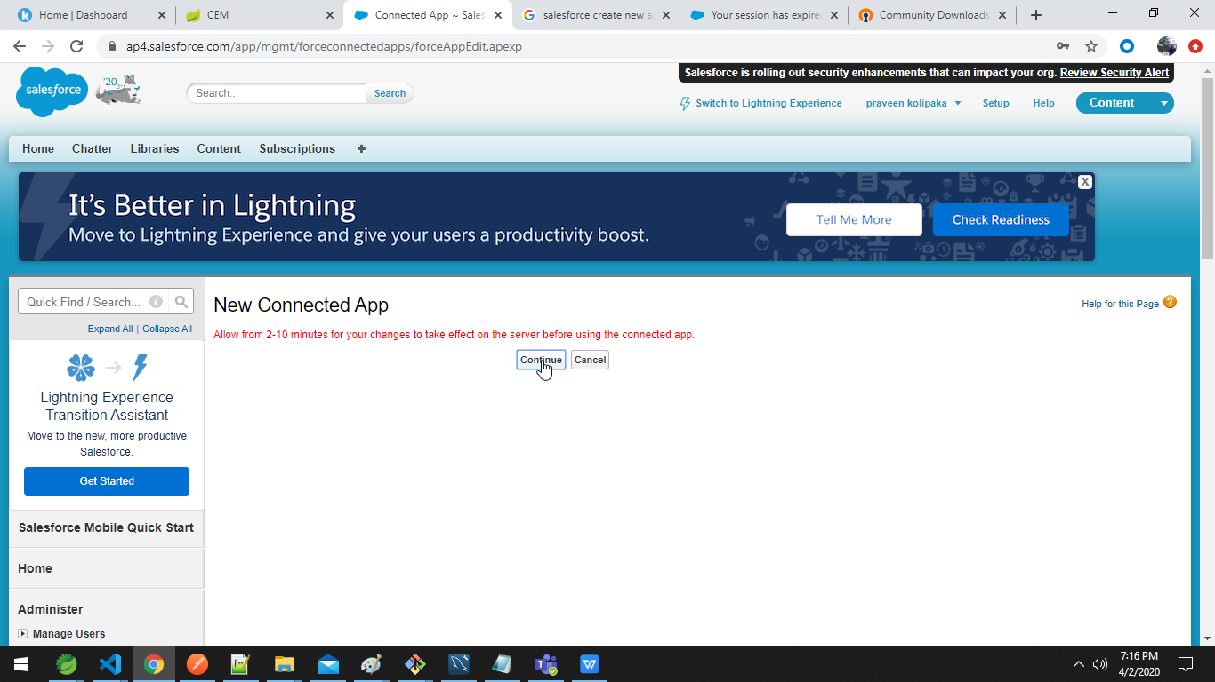

- Click on app name

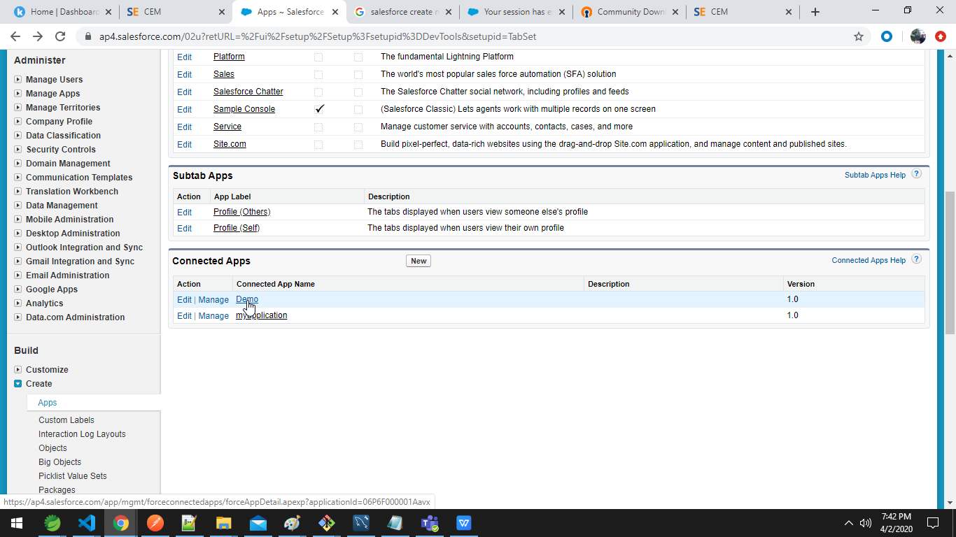

- The consumer key is also known as client id and consumer secret is also known as client secret

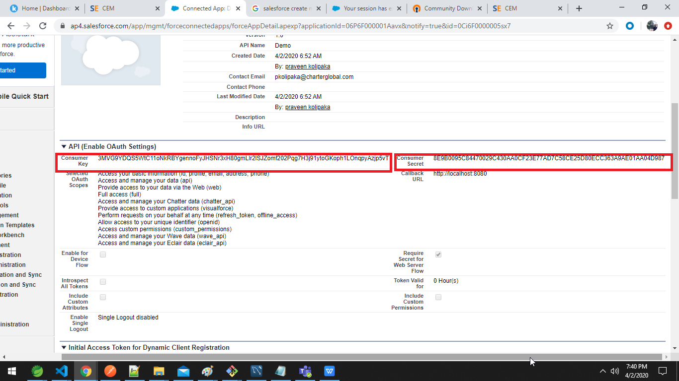

- For the security token click on ‘My Settings’ > Personal > Reset my security token

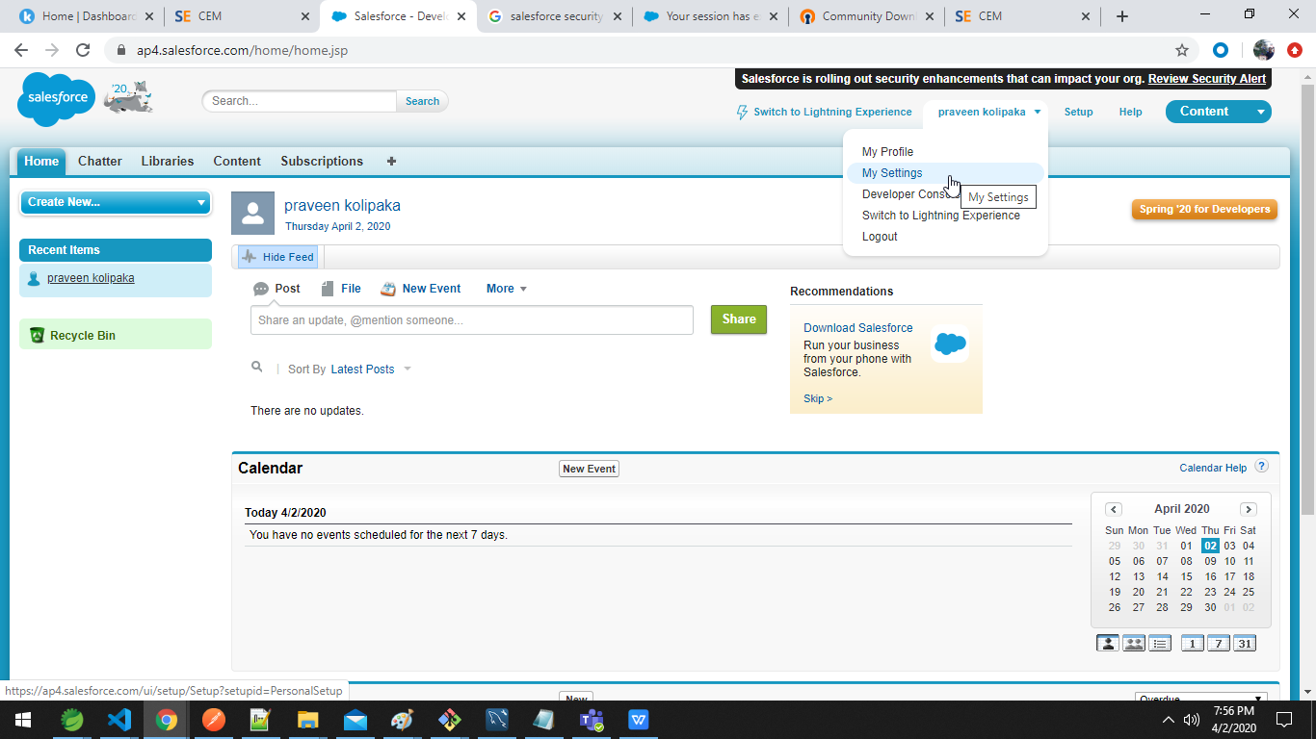

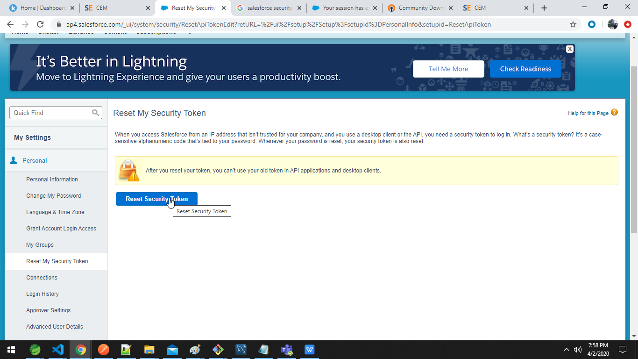

- The security token is sent to email.

